Standard Error of The
Mean, comparison between two groups, t-test

Let us begin with comparison of Population and Sample drawn from it
• To which extend is the Mean and SD of a random sample (drawn from a specific population) are estimates of the population’s Mean and SD?

Let us assume that our real population is…
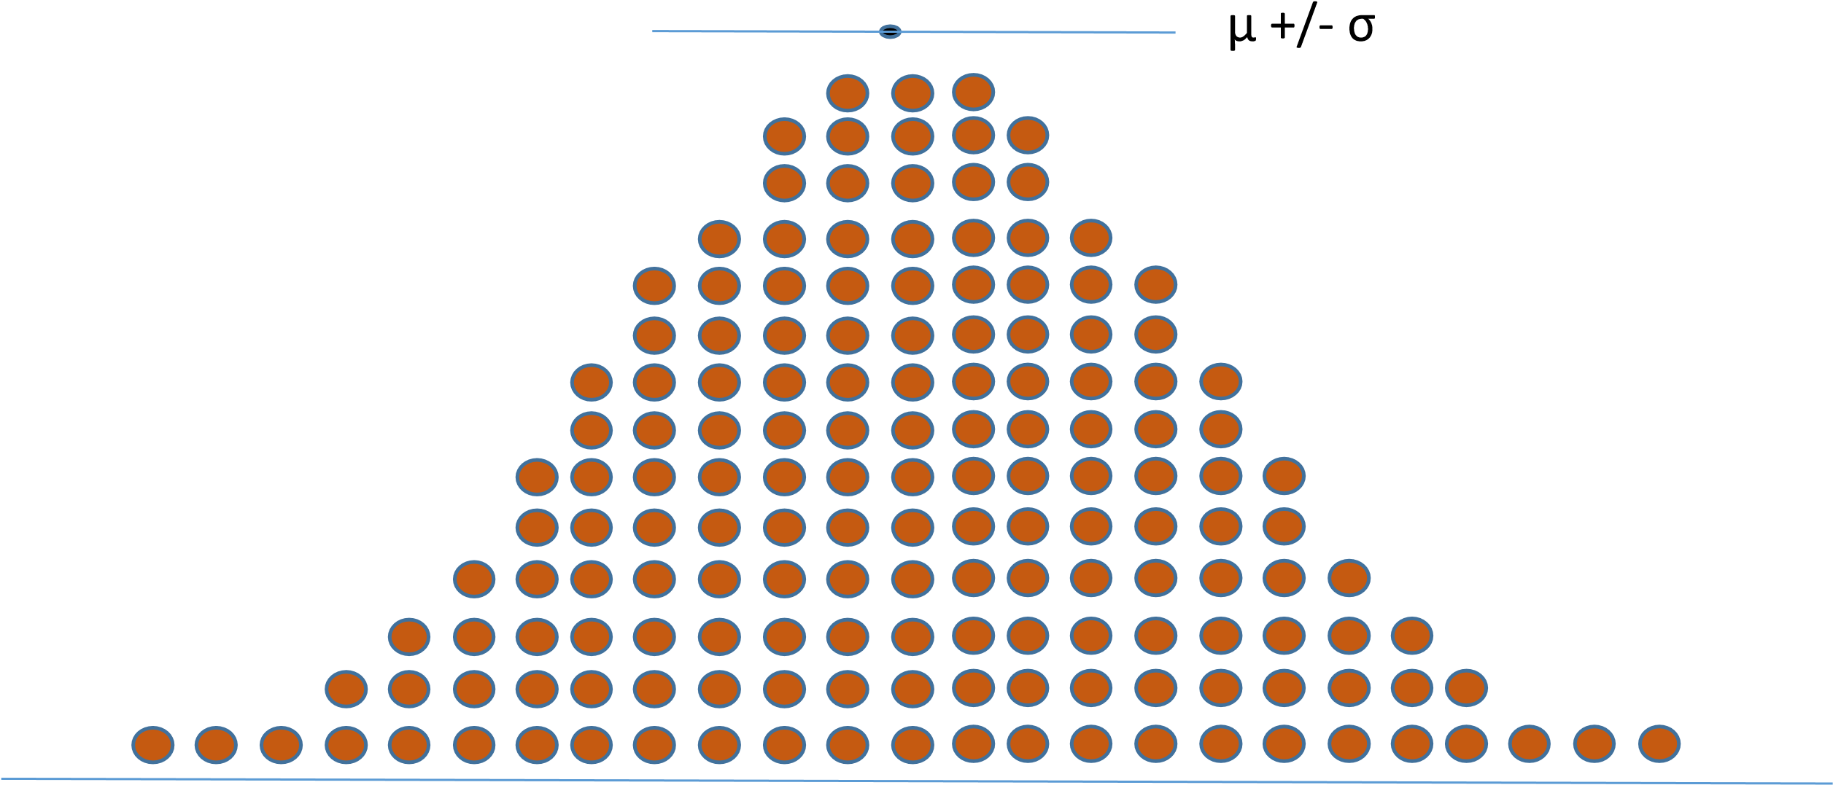

We can sample from our population at ransom (forming a Sample 1)
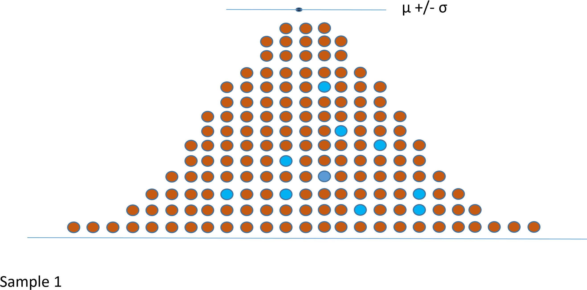
(n=10)

Let us now select Sample 2
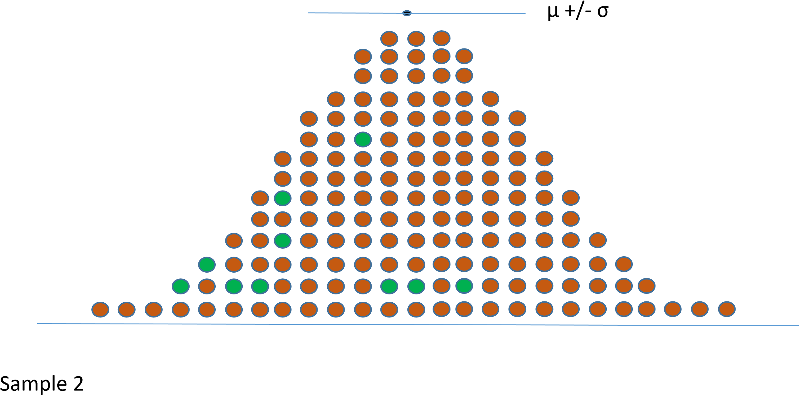
(n=10)

- As you can see samples are different, their Means and SDs are different.
- Some are closer to the actual population Mean and SD and some are further.
- Let us now consider Means of many possible random Samples of size 10 from this population and let us depict their distribution…

Means for Sample 1 and Sample 2
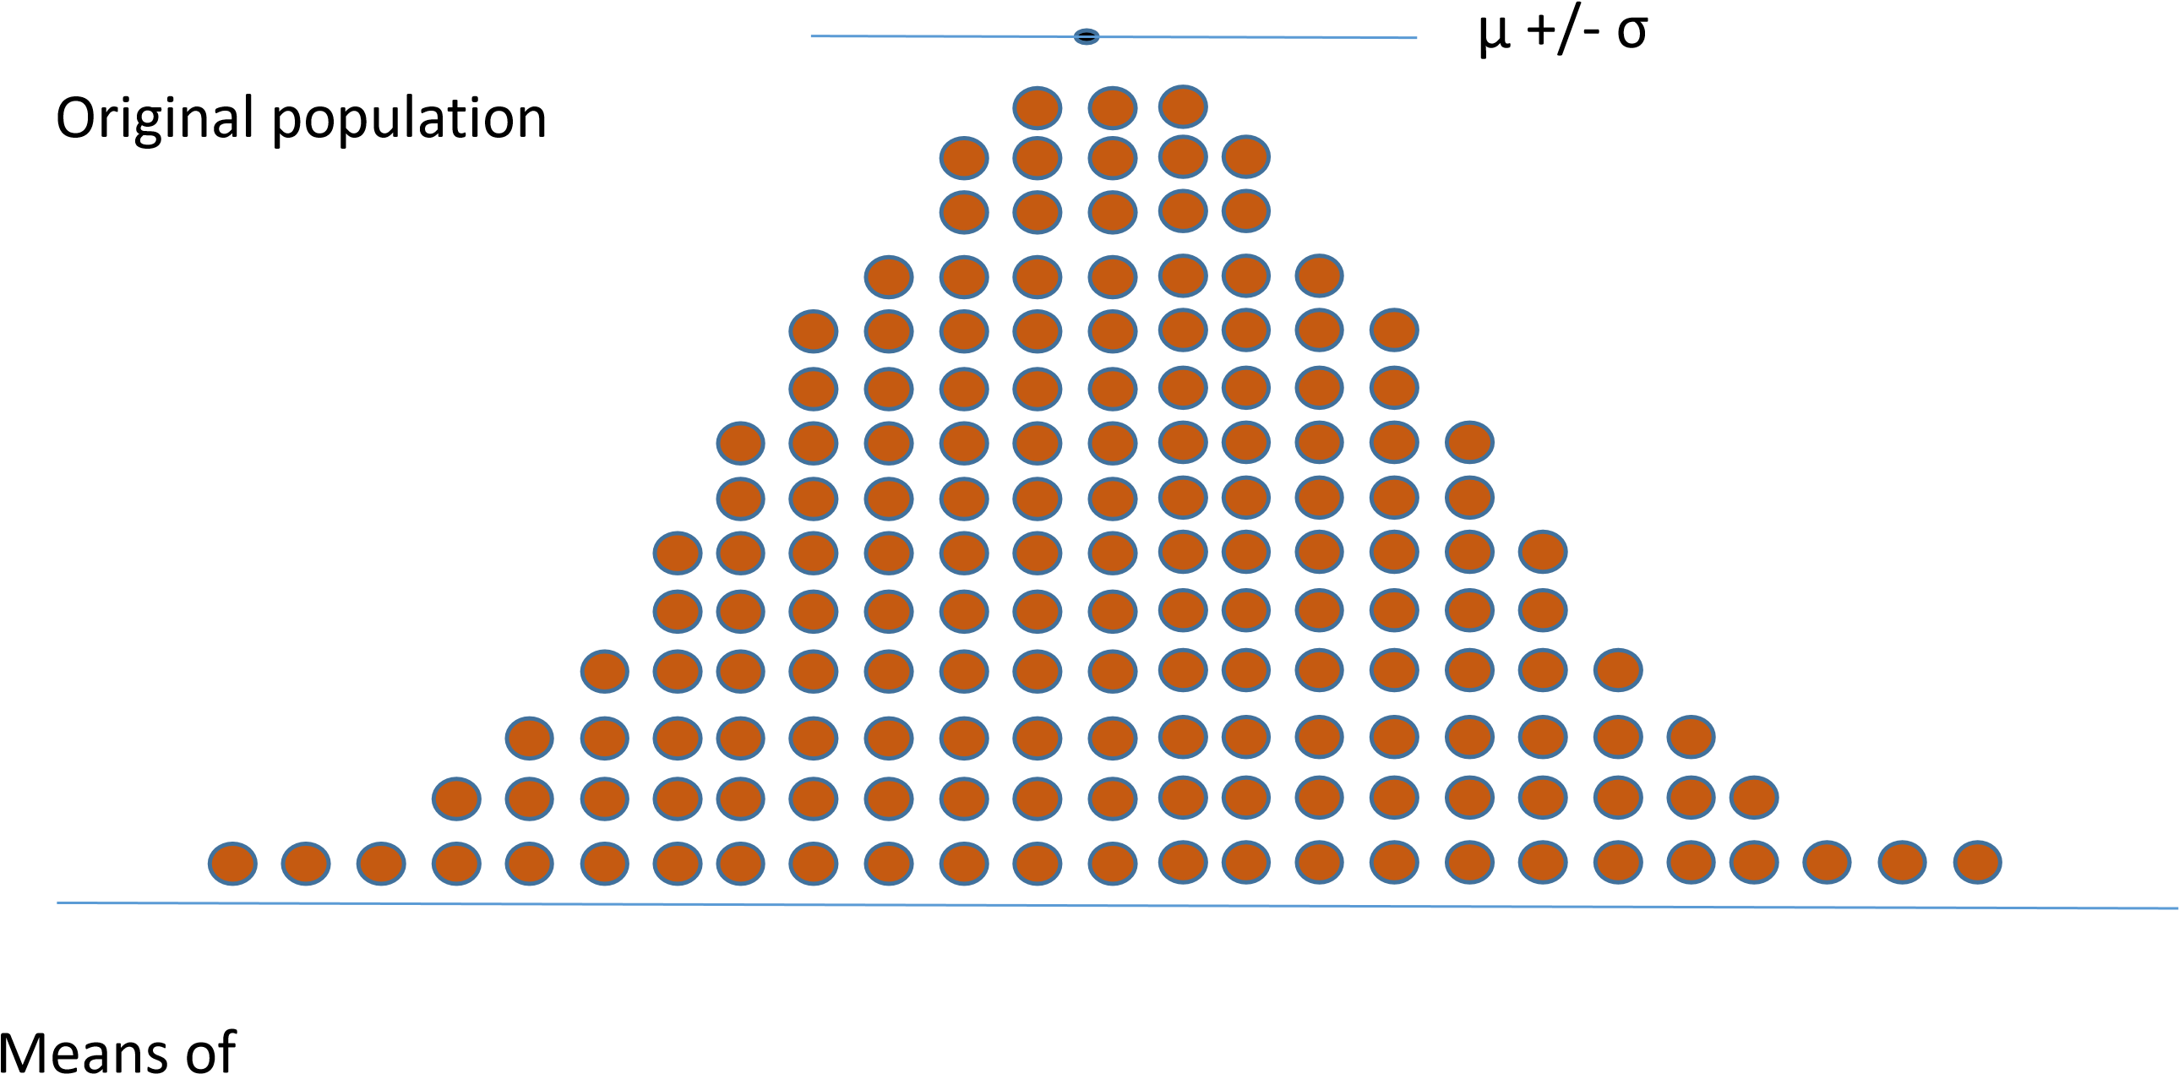
Sample 1 and
Sample 2 Sample 2 Mean Sample 1 Mean

Distribution of Sample Means
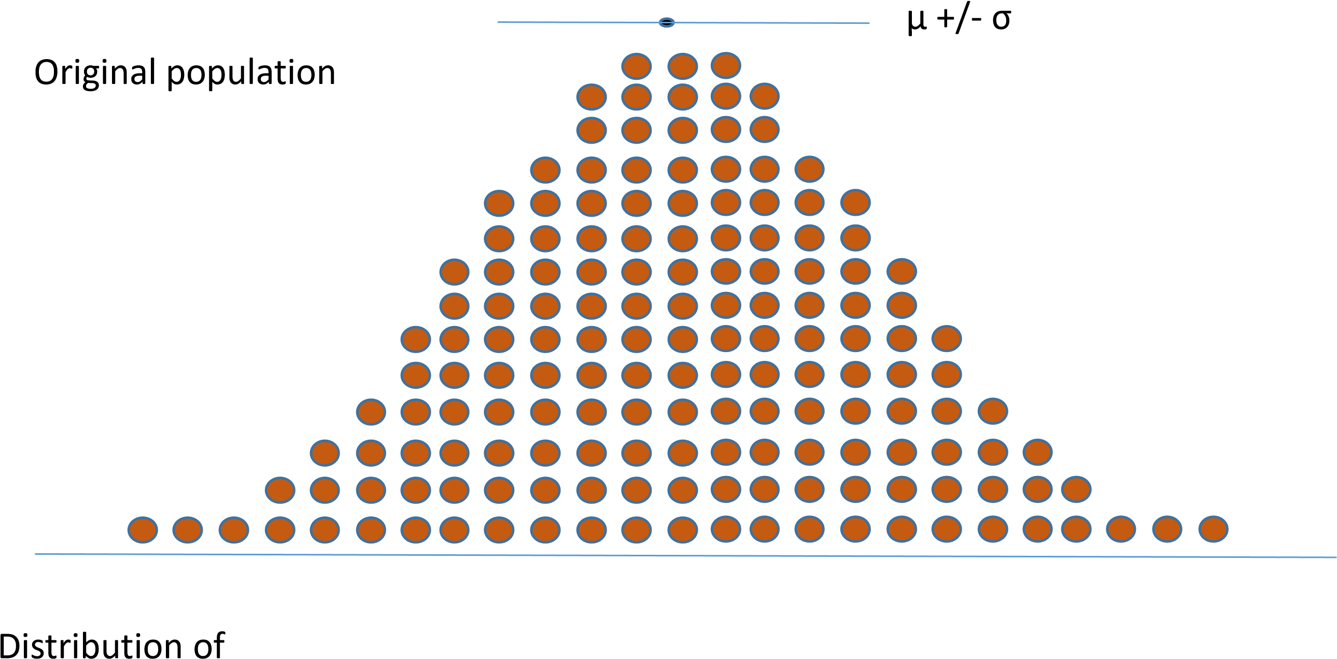
Sample Means
(for many samples)
- Interestingly, the distribution of the Sample Means follows Normal Distribution
Central Limit Theorem: when the variable of interest is the sum of the many other independent random variables, its distribution will tend to be Normal, thus the distribution of the Means (i.e., Mean is equivalent to the Sum) of the samples will tend to be Normal.
- Note that the more samples we collect, the better will be our approximation of this distribution

Let us compute Mean of this Sample Mean distribution
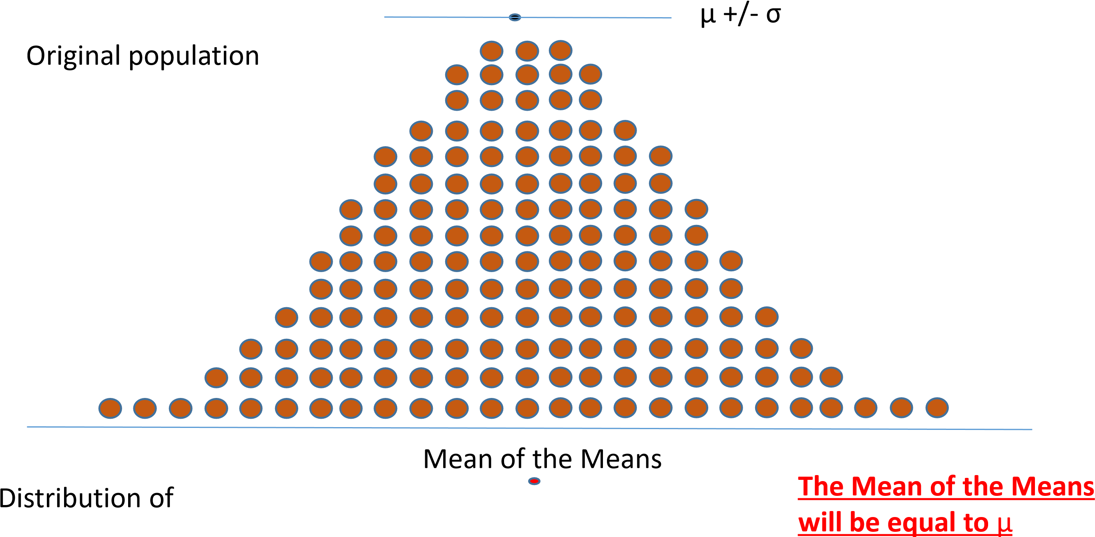

Let us compute SD of the Sample Mean distribution
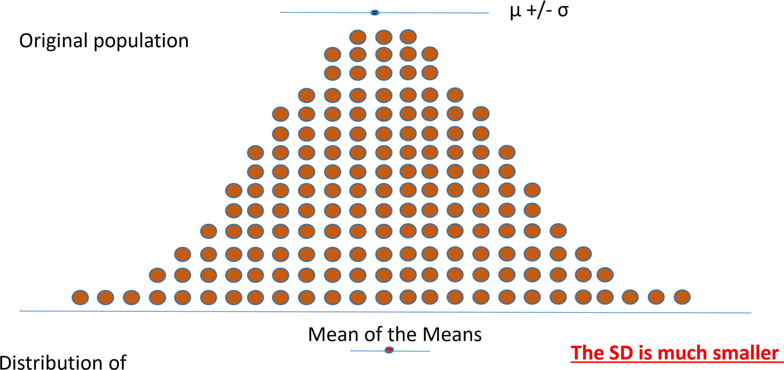
than the SD (σ) of the whole population

Let us compute SD of the Sample Mean distribution
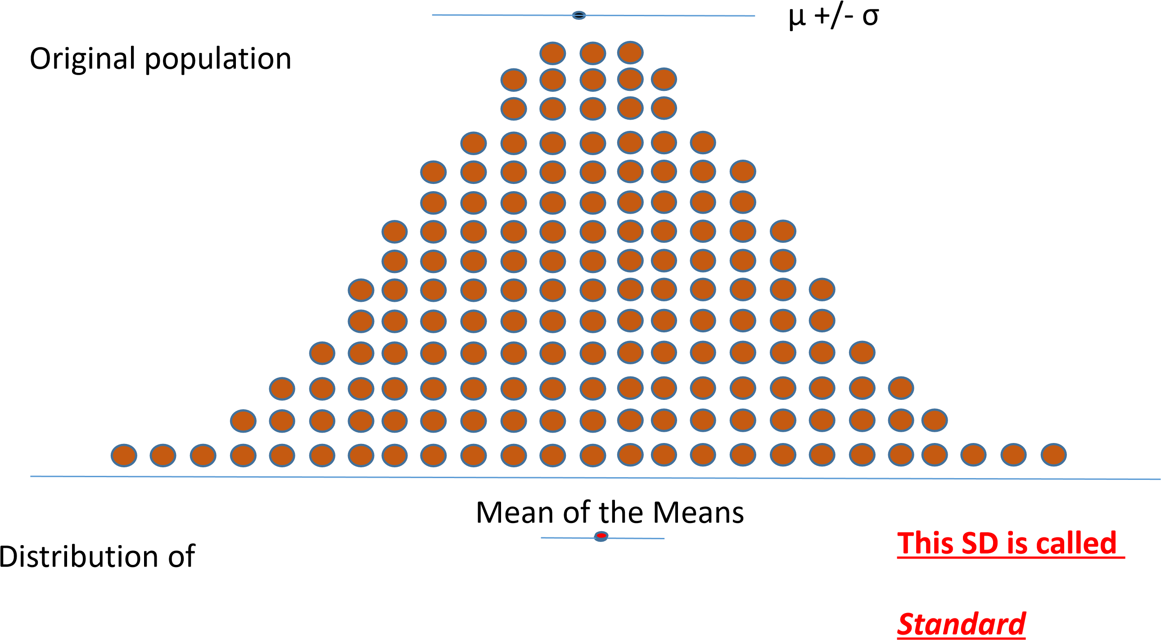
Error of The Mean (SEM)

Observation
- Note that as the Sample size increases, the more precise we will be about the Mean of each Sample (when compared to the whole Population) and the
smaller will be SEM (meaning closer we are to the ACTUAL POPULATION MEAN)
- On the other hand, the larger the SD of the original Population, the more variability will be in samples drawn from it and thus will cause SEM to be high

Standard Error of the Mean (SEM)
• The true standard error of the mean of Sample of size “n” drawn from a population with SD σ is
σ_{x} = σ/sqrt (n)
Since we usually do not know σ, the best estimate of σ_{x} from a single Sample is
s_{x} = SD/sqrt (n)
Interestingly, a true (unobserved) mean will fall within 1.96 standard errors of the Sample Mean in 95% of the time.

SD and SEM are totally different
- Note that SD and SEM are totally different and reflect DIFFERENT things
- SEM is much smaller than SD (in fact smaller by the factor sqrt(n)
They are very often misused…. (you need to be careful about using one or the other)
- Think: what does each mean?

Parametric vs non-parametric tests/statistical methods
- Parametric tests : assume that the population from which the samples were drawn can be completely described by specific parameters, for example Mean and SD (for example, if data are normally distributed, you can use a parametric test) (e.g., t-test)
- When this assumptions cannot be held, we will use non-parametric tests (e.g., Kruskal–Wallis, Wilcoxon signed-rank test)
- Let us start with talking about parametric tests…
How can we compare two groups (parametric test)?
- There is a special parametric procedure that allows you to test differences between two groups: t-test
(also called Student t-test)
- It is the most common procedure in medical literature
- This is a parametric test

Example 1
• Let us assume that we want to test a new drug that is an effective diuretic. For simplicity, let us assume that we have 10 patients, 5 of which will receive placebo and 5 of which will receive this drug, and then we measure each patient’s urine production for 24 hours.

This table reflects our observations
Group | Urine production ml/day
Patient 1 (placebo) | 1000
Patient 2 (placebo) | 1100
Patient 3 (placebo) | 1100
Patient 4 (placebo) | 1200
Patient 4 (placebo) | 1400
Patient 5 (drug) | 1200
Patient 6 (drug) | 1300
Patient 7 (drug) | 1400
Let us plot our observations….
Placebo group X n=5

800 1000 1200 1400 1600 1800 2000
Urine production ml/day
Drug group Y
n=5

Let us calculate mean and SD for these groups
Group | Urine production ml/day
Patient 1 (placebo) | 1000
Patient 2 (placebo) | 1100
Patient 3 (placebo) | 1100
Patient 4 (placebo) | 1200
Patient 4 (placebo) | 1400
Patient 5 (drug) | 1200
Patient 6 (drug) | 1300
Patient 7 (drug) | 1400
Mean 1 (placebo)=
(1000+1100+1100+
1200+1400)/5 = 1160
Mean 2 (drug)=
(1200+1300+1400+
1500+1600)/5 = 1400

Let us indicate Mean 1 and Mean 2
Placebo group X
Mean 1 = 1160 n=5

800 1000 1200 1400 1600 1800 2000
Urine production ml/day
Drug group Y
n=5
Mean 2 = 1400

What about SD? (please make calculations by hand as a practice)
Group | Urine production ml/day
Patient 1 (placebo) | 1000
Patient 2 (placebo) | 1100
Patient 3 (placebo) | 1100
Patient 4 (placebo) | 1200
Patient 4 (placebo) | 1400
Patient 5 (drug) | 1200
Patient 6 (drug) | 1300
Patient 7 (drug) | 1400
SD = 151.66
SD = 158.1

Let us indicate Mean +/- SD
Placebo group X
1160 +/- 151.66 n=5

800 1000 1200 1400 1600 1800 2000
Urine production ml/day
Drug group Y n=5
1400+/- 158.1

We will compare two things:
- So, basically we will compare Difference in the Sample Means and
Amount of variability expected within the samples (i.e., Standard Error of this difference)
- Called t = Difference in Sample Means/SE of Difference of
Sample Means

Step 1: Difference in Means
- Thus, our FIRST step is to compare Means of these samples (i.e., compare sample means).
Mean_{X} - Mean_{Y}
- Note that if there was no difference between the placebo and the drug group, in that case , there would be very little difference between Mean 1 and Mean 2.

Step 2: Compute Standard Error of the difference between Means
• Compute and evaluate Standard Error of the difference between Means.
Let is visualize this difference….
Placebo group
1160 +/- 151.66 n=5

800 1000 1200 1400 1600 1800 2000
1160 +/- 151.66

1400+/- 158.1

Difference between the means = 1400-1160 = 240
Urine production ml/day
Drug group n=5 1400+/- 158.1

800 1000 1200 1400 1600 1800 2000
Urine production ml/day

We can select more and more samples and plot difference between their Means… (like we did before)
Mean of the Differences
Distribution of
Differences
between the Means
Note that the difference is mathematically equivalent to the sum… thus their distribution will be Normal….

SD of the difference between Means (Standard Error)
It is a known fact that the variance of the difference between the two variables selected at random equals the sum of the variances of the two populations from which the samples were drawn.
sX-Y = sX + sY
So, if we want to translate this back to SD for the Difference between the Means: since variance is SD² SD2X-Y = SD2X + SD2Y
SD_{X-Y} = sqrt (SD²_{X} + SD²
Y
)
SEM for X SEM for Y

Coming back to “t”
• t= Difference of Sample Means/ SE of the Difference of Sample Means t= (Mean_{X} - Mean_{Y})/ sqrt (SD²_{X} + SD²_{Y})
t= (Mean_{X} - Mean_{Y})/
sqrt ((SD_{X} /sqrt(n_{X}))²+ (SD_{Y}/sqrt(n_{Y})))² )

To simplify
t= (Mean_{X} - Mean_{Y})/ sqrt (SD²_{X} /n_{X}+ SD²_{Y}/n_{Y}) where “n” is the size of each sample
Think: what will “t” depend on? (Hint: Means, SDs, sample sizes)

If we select more and more pairs of samples (of size 5) and plot their t-scores,
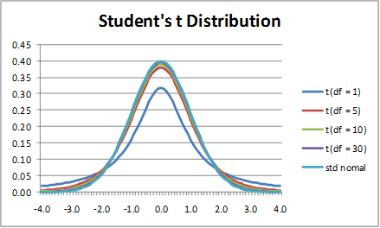
they will follow t-distribution

Where df (degree of freedom) is
- Degree of freedom for t-distribution is defined as
- (n_{X} -1) + (n_{Y} -1) = n_{X} + n_{Y} -2
For degree of freedom 8, t=2.3 and t = -2.3 would corresponds to 95% confidence interval

95% confidence interval for different degrees of freedom
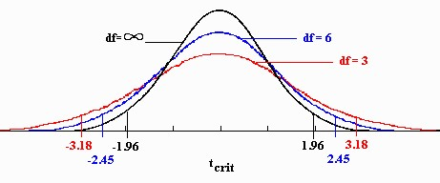

Notes
- Note, Student t distribution is different from Normal distribution AND their confidence intervals are embraced by different values of “z”/“t”.
- 95% confidence interval would vary depending on the degree of freedom to the t-distribution
- As sample size increases (i.e., goes to infinity), tdistribution will approximate Normal.

PE 1
• What is a t-score and its significance when comparing two populations of 61 patients each: Mean1 = 49, Mean 2=41. SD1= 21, and SD2=22.
Please find a t-distribution table online (pay attention to the degrees of freedom, show your calculations)

PE 2
• Explain the effect of the sample Means, their SDs, and sample sizes on the value of “t”

HW
- Please do PE6 by Tuesday Oct 23rd, I will post solutions on Wednesday Oct 24th.
- I will prepare a sample Midterm test (just for you to practice and get familiar with my types of questions) – your score will no affect your final grade – this is just for your practice
- I will give you 3-4 days to complete it online. We will start our next lecture with discussing the sample Midterm results+ answers.
- Optional reading: Chapter 5 from the “Primer of Biostatistics”

